Professional Wedding
Videography

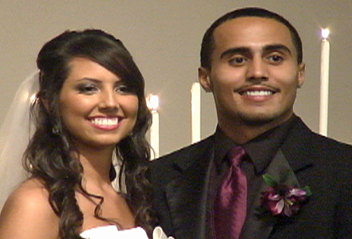
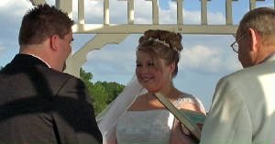
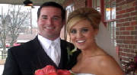

Package Options
(see back for package descriptions)
Ceremony Only $350
Reception Only $200
Ceremony & Reception Package $550

Grant Keller Weddings
www.grantkellervideography.webstarts.com
(870) 530-3249
GrantKellerWeddings on

Ceremony ONLY Package ($350) includes:
- Videographer arrives 90 minutes prior to ceremony start time for set-up and filming of any pre-ceremony activities.
- Two cameras are used to capture different angles, as well as close-ups and wide shots.
- Cameras are mobile with no cords for easy movement and fast set-up.
- Wireless microphone is used during the ceremony to capture vows and other dialogue.
- Fully edited ceremony video includes professional special effects such as animated transitions, slow motion, titles, music, etc.
- Receive 2 copies your wedding DVD in hard cases featuring pictures of the bride and groom. Extra copies may be purchased for $10.00 each.
- Wedding DVD includes Title and Chapter Menus for easy navigation.
- (optional) DVD includes wedding party credits and any special thanks you wish to send to family and guests.
- (optional) DVD includes private interview of Bride and Groom about the marriage proposal, their first date, etc.
- (optional) Request special love songs to be used on your wedding DVD.

Reception ONLY Package ($200) includes:
- Videographer attends and captures the reception for a maximum of 2 hours. When planning your reception, anything you want to appear in your video needs to occur during the first 2 hours of the reception (special dances, cake cutting, garter/bouquet toss, etc.). At your request, the videographer may stay beyond the 2 hours maximum for a price of $100 per extra hour.
- Two cameras are used to capture different angles, as well as close-ups and wide shots.
- Video includes footage of reception decorations and arrangements.
- Wireless microphone may be used during portions of the reception to capture dialogue (during special dances, cake cutting, garter/bouquet toss, etc.).
- (optional) Video well wishes from members of your wedding party and your guests.

Ceremony & Reception Package ($550) includes:
ALL of the Above

