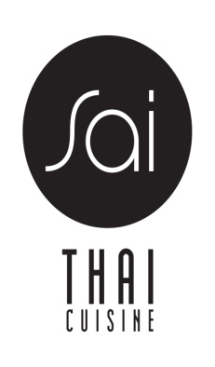

GLUTAN FREE MENU

SAI THAI SPICY BEEF SALAD 18
SPICY LETTUCE WRAP 12
SALMON GREEN CURRY 20
SALMON RED CURRY 20
CRISPY DUCK WITH RED CURRY SAUCE 25
MASAMAN PINEAPPLE 18
LOBSTER & SCALLOP MASAMAN 25
COCONUT SOUP WITH CHICKEN 10
COCONUT SOUP WITH SHRIMP 12
SPICY LEMONGRASS SOUP WITH CHICKEN 10
SPICY LEMONGRASS SOUP WITH SHRIMP 12
*PLEASE LET YOUR SERVER KNOW THAT YOU ORDER FROM GLUTEN FREE MENU

